Lab 4

1. For the deterministic scale free network having 10,000 nodes, determine the average path length, diameter, node and edge betweenness and their distribution. Write your observations.

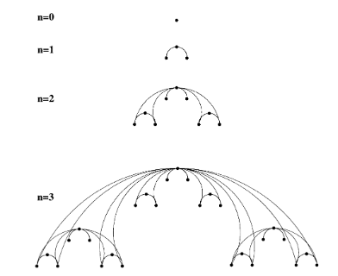

Generate a probabilistic version of the above network of having the same number of nodes such that the replicas that you have generated into the step 2 are to be connected to the hub node with some probability p. You have to follow the same methodology in the step 3 where you have to generate the two replicas of existing network and connect their hubs with probability p. Note that the probability values should vary in a interval of 0.1 such that you have to generate a graph with probability of connection to hubs as 0.05, another graph with p=0.15 and so on i.e. graphs {0.05,0.15,0.25,0.35,0.45,…,0.95}. Determine the average path length, diameter, node betweenness and edge betweenness and the distribution of node and edge betweenness. Note that, as we have discussed in the Thursday’s class on 3rd Sept, you have to normalize the node/edge betweenness to determine the distribution of node and edge betweenness by dividing with nC2.

There is no need to determine average clustering coefficient for this graph because it would be zero.

1. For the random graph having 10,000 nodes determine the average path length, diameter, average clustering coefficient, node and edge betweenness and their distribution. Write your observations. Note that the probability values should vary in a interval of 0.1 such that you have to generate a graph with probability of connection to hubs as 0.05, another graph with p=0.15 and so on i.e. graphs {0.05,0.15,0.25,0.35,0.45,…,0.95}. If you have the csv file of the old code that you have generated into Lab 3, you may reload it. I have no objection with it.

Note that both of the above type of networks except the deterministic networks are to be generated in probabilistic fashion. Hence, if you will generate the network the network in this manner two times, their properties would differ as both of them are a type of random graphs. Hence, we cannot be able to get any insight with respect to the generation of graph in only one iteration. Hence, you should generate each of these graph with respect to each p 100 times. You have to also the probability distribution of clustering coefficient of each node in only iteration in the second question.